Completing a Questionnaire Please follow the instructions in this document to access the **Instructions From Microsoft** page (see example in Figure 2) and to complete and submit the questionnaire.

The **Instructions From Microsoft** page (Figure 2) contains a request to upload case documents. See “Uploading Case Documents” for instructions on uploading the required documents for your case.

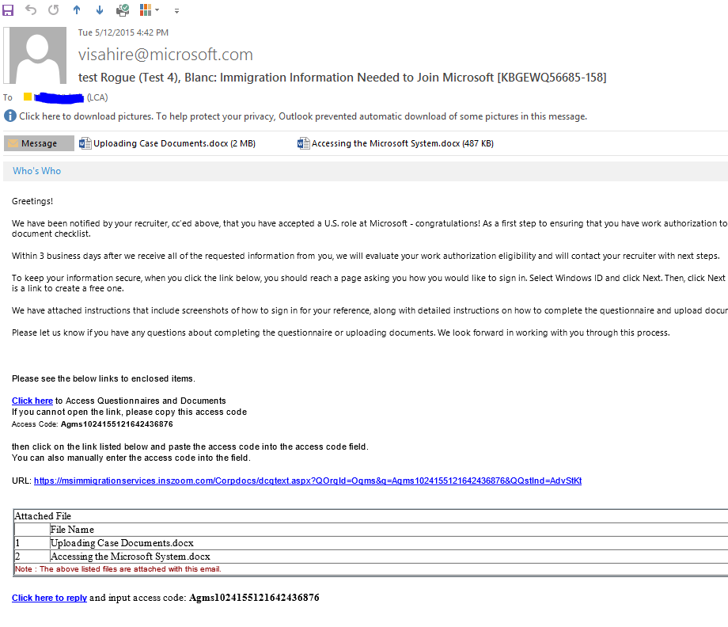

Figure 1

1. Access the questionnaire by clicking **Click here** in the email (highlighted in Figure 1). If the link does not work, complete the following steps:
   1. Copy the access code from the email (highlighted in Figure 1).
   2. Click the URL link (highlighted in Figure 1).
   3. In the dialog box that appears, paste the access code in the text box and click **OK**.
2. On the **Instructions From Microsoft** page that appears, click **Click here to Edit**

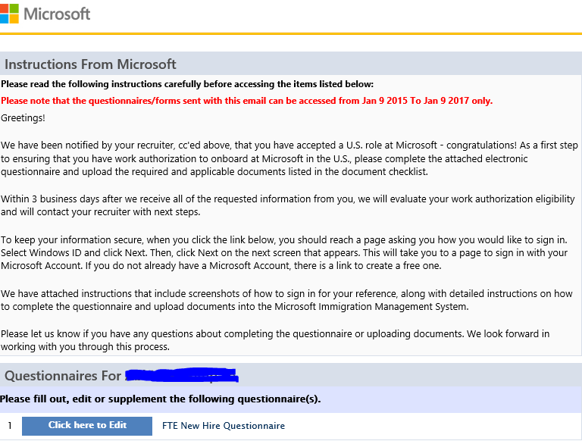

*Figure 2*

1. On the **Applicant Information** portion of the questionnaire, under **Personal Information**, click **Click here to Edit**

(highlighted in Figure 3). 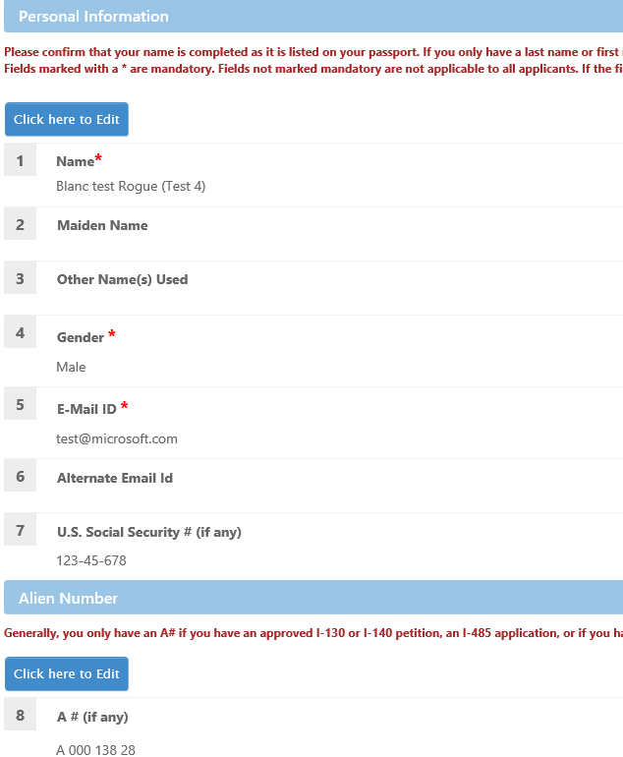

*Figure 3*

1. In the dialog box that opens, fill in the information, and then click **Save and Next** (highlighted in Figure 4).

Repeat this step for all of the dialog boxes that appear.

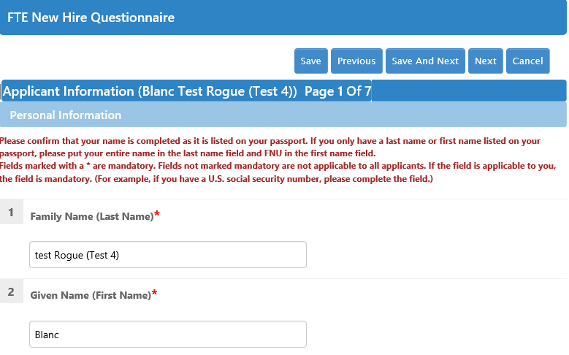

Figure 4

**Note** All of the fields marked with a red asterisk are required.

**Important** Always click **Save and Next** to be sure that your changes are saved. If you click **Next** only, your changes will not be saved.

1. When you reach the final page of the questionnaire, the **Save and Next** button will no longer be available. On that page, click **Save**.
2. On the questionnaire page that appears, click **Go to Questionnaires List**.
3. If the **Instructions From Microsoft** page contains a **Case Docs Check List** section, follow the instructions in “Uploading Case Documents,” otherwise proceed to the instructions in the following “Informing Microsoft” section

## Informing Microsoft

When you have completed all of the instructions in the **Instructions From Microsoft** page, follow this procedure to inform Microsoft:

1. At the bottom of the **Instructions From Microsoft** page, below the **Case Docs Check List**, click **Inform Microsoft** (highlighted in Figure 5).

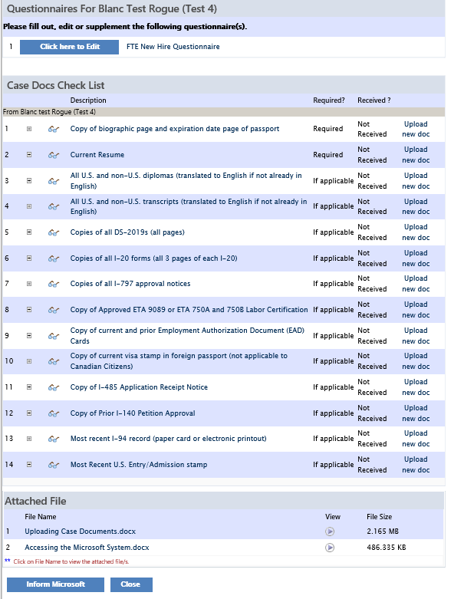

Figure 5

**Important** Read the warning in the message that appears and be sure that all of the information is accurate. You will not have access to edit or update your questionnaire after you submit it.

1. If you are satisfied that all of the information is accurate, click **OK** in the warning message box. Otherwise, click **Cancel**.
2. In the **Send Email** dialog box that appears, check that the **From** email address is a correct email address for you and make any additions to the email that you believe are necessary. If you do not have any questions for the email recipient, you do not need to make any edits to the email.

**Important** Do not change the **To** email address or the **Subject** text.